**ROADWAY TRAVELS**

**“Roadway Travels”** is in business since 1977 with several buses connecting different places in India. Its main office is located in Hyderabad.

The company wants to computerize its operations in the following areas:

* + Reservations
  + Ticketing
  + Cancellations

### Reservations:

Reservations are directly handeled by booking office, reservations can be made 60 days in advance in either cash or credit. In case the ticket is not available ,a wait listed ticket is issued to the customer. This ticket is confirmed against the cancellation.

### Cancellation and modification:

Cancellations are also directly handed at the booking office. Cancellation charges will be charged.

Wait listed tickets that do not get confirmed are fully refunded.

|  |  |
| --- | --- |
| **ExpNo:1** |  |

### AIM: Analyze the problem and come with the entities in it. Identify what Data has to be persisted in the databases.

The Following are the entities:

**1 .Bus**

1. **Reservation**
2. **Ticket**
3. **Passenger**
4. **Cancellation**

**TheattributesintheEntities: Bus:( Entity)**



Destination

Source

CouchType

BusNo

**Bus**

**Reservation(Entity)**



ContactNo

BusNo

No-of-Seats

Journeydate

Address

PNRNO

**Reservation**

**Ticket:(Entity)**



Dep-Time

Source

Age

Sex

Journeydate

Destination

TicketNo

BusNo

**Ticket**

**Passenger:**



ContactNO

Age

Sex

PNRNO

Name

TicketNo

**Passenger**

**Cancellation(Entity)**



SeatNo

Journeydate

ContactNo

PNRNO

**Cancellation**

**ConceptdesignwithE-RModel:**

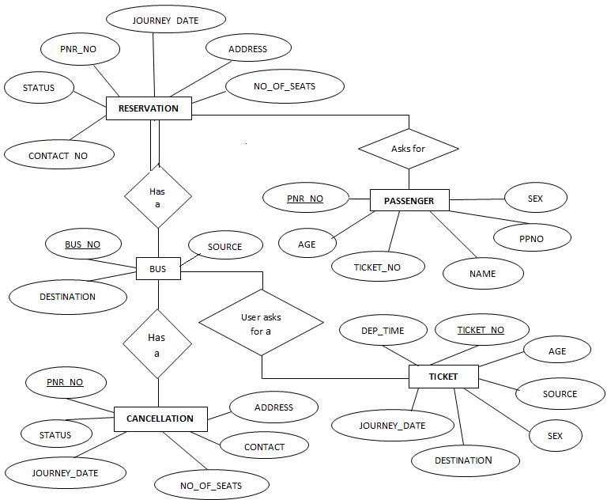

# WEEK-1

CREATIONOFTABLES

## Create a table called Employee with the following structure.

|  |  |
| --- | --- |
| **Name** | **Type** |
| Empno | INT |
| Ename | Varchar(10) |
| Job | Varchar(10) |
| Mgr | INT |
| Sal | INT |

* + 1. **Add a column commission with domain to the Employee table.**
    2. Insert any five records into the table.
    3. Update the column details of job
    4. Rename the column of Employ table using alter command.
    5. Delete the employee whose Emp no is105.

**SOLUTION:**

SQL> create table employee(empno INT, ename varchar(10),job varchar(10),mgr INT, sal INT);

Table created.

SQL>desc employee;

Name Null? Type

EMPNO INT

ENAME VARCHAR(10)

JOB VARCHAR(10)

MGR INT

SAL INT

## Adda column commission with domain to the Employee table.

SQL> alter table employee add(commission INT); Table altered.

SQL>desc employee;

Name Null? Type

EMPNO INT

ENAME VARCHAR(10)

JOB VARCHAR(10)

MGR INT

SAL INT

COMMISSION INT

## Insert any five records in to the table.

SQL>insert into employeevalues(&empno,'&ename','&job',&mgr,&sal,'&commission'); Enter value for emp no: 101

Enter value for ename: abhi

Enter value for job: manager

Enter value for mgr:1234

Enter value for sal:10000

Enter value for commission:70

old1:

insert into employee values(&empno,'&ename','&job',&mgr,&sal,'&commission')

new 1: insert into employee values(101,'abhi','manager',1234,10000,'70')

1 row created.

SQL>/

Enter value for empno:102

Enter value forename: rohith

Enter value for job: analyst

Enter value for mgr: 2345

Enter value for sal: 9000

Enter value for commission: 65

old1: insert into employee values(&empno,'&ename','&job',&mgr,&sal,'&commission')

New 1: insert into employee values(102,'rohith','analyst',2345,9000,'65')

1 row created.

SQL>/

Enter value for empno:103

Enter value for ename:david

Enter value for job:analyst

Enter value for mgr: 3456

Enter value for sal: 9000

Enter value for commission: 65

old1:insert into employee values(&empno,'&ename','&job',&mgr,&sal,'&commission')

new 1: insert into employee values(103,'david','analyst',3456,9000,'65')

1 row created.

SQL>/

Enter value for empno:104

Enter value for ename:rahul

Enter value for job:clerk

Enter value for mgr: 4567

Enter value for sal: 7000

Enter value for commission: 55

old1:insert into employee values(&empno,'&ename','&job',&mgr,&sal,'&commission')

new 1: insert into employee values(104,'rahul','clerk',4567,7000,'55')

1 row created.

SQL>/

Enter value for empno:105

Enter value for ename:pramod

Enter value for job: salesman

Enter value for mgr:5678

Enter value for sal:5000

Enter value for commission: 50

old1: insert into employee values(&empno,'&ename','&job',&mgr,&sal,'&commission')

new 1: insert into employee values(105,'pramod','salesman',5678,5000,'50')

1 row created.

SQL>select *from employee;

EMPNOENAME JOB MGRSALCOMMISSION

|  |  |  |  |  |
| --- | --- | --- | --- | --- |
| 101abhi | Manager | 1234 | 10000 | 70 |
| 102 rohith | Analyst | 2345 | 9000 | 65 |
| 103 david | Analyst | 3456 | 9000 | 65 |
| 104 rahul | Clerk | 4567 | 7000 | 55 |
| 105 pramod | salesman | 5678 | 5000 | 50 |